“Mixer” size and control Bug
Windows 10 Home HP pavilion Laptop
Figure 1 this is with Windows 10 and setting my windows (10)size at 150%
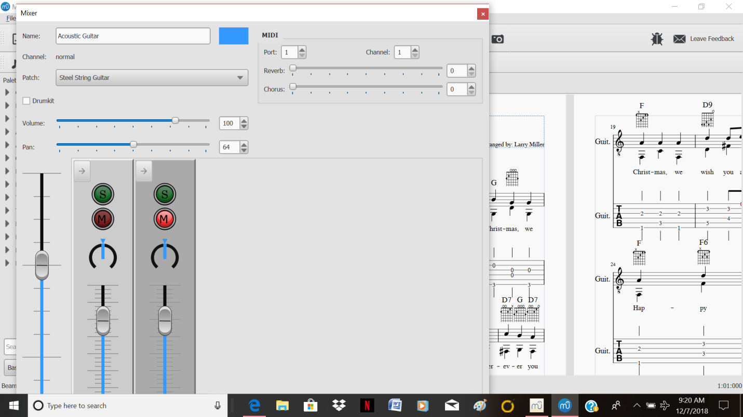

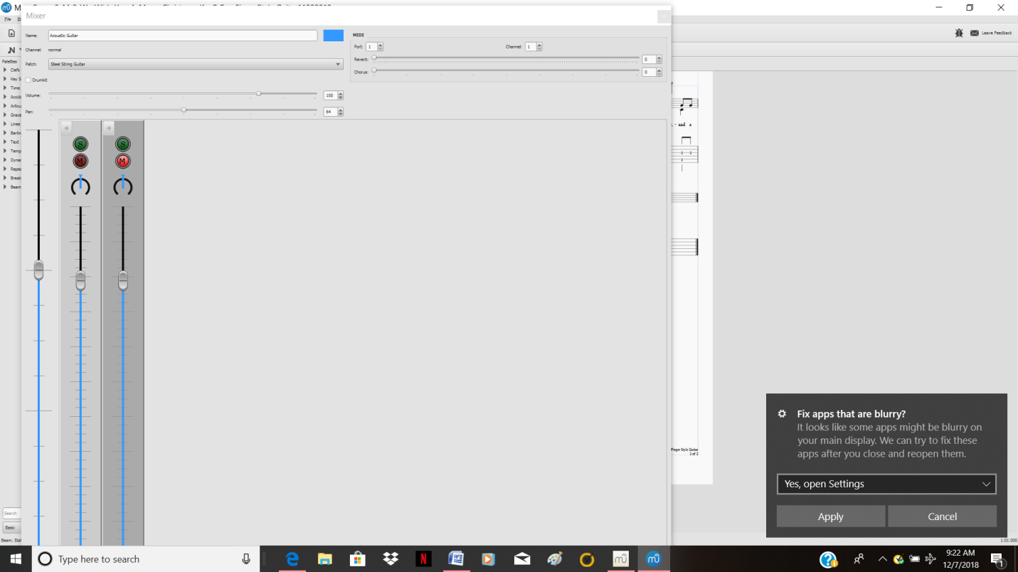

Figure 2 this is with Windows 10 and setting my windows (10) size at 125 %

“Mixer” size and control Bug
Windows 10 Home HP pavilion Laptop

When I try to click the edges to resize sometimes it closes it out and will not reselect without restarting MuseScore 3 beta. The mixer panel seems to always be too large for the screen. Can’t see the bottom of the Mixer panel.

The Mixer will not resize when I am at 150%. It seems to partially work if I keep my screen size at 125%. However for my eye sight this is too small to work with.

