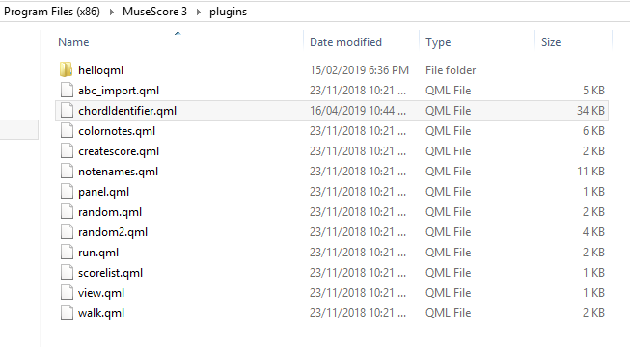
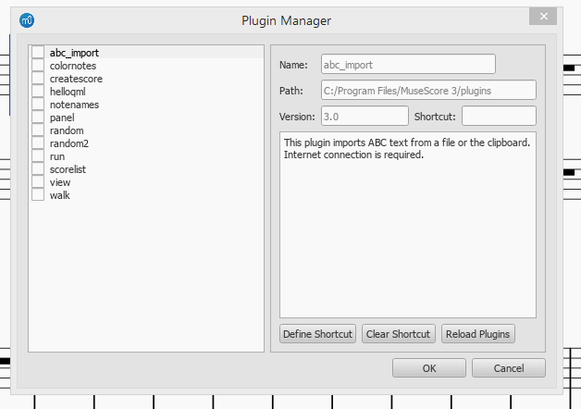
I did follow the guidance of Jojo-Schmitz, in Musecore not see ChordIdentifier, JoJo-Schmitz help me,thanks.

