Here’s what happened when I deleted the notes from the measure. Why the extra 8th note?
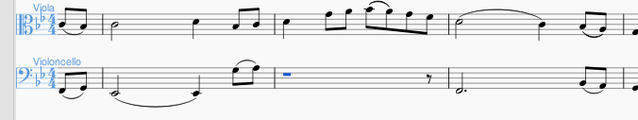
I had selected 3 of the 4 quarter notes and hit the delete key. Presto chango! There’s an extra rest!

The original measure held only 4 quarter notes. When I did ctrl-z to try to get back to the original form of the measure, here’s what I got!
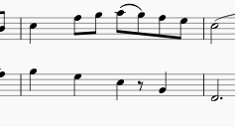
I hadn’t played with any triplets.
I had only one voice here (hmm, although I had a second voice for a couple measures at the beginning of this part) but it didn’t respond to trying to delete it as if it were in another voice. It firmly insists that it belongs as part of the first and only voice (we had a long conversation and it continues in its delusion).

