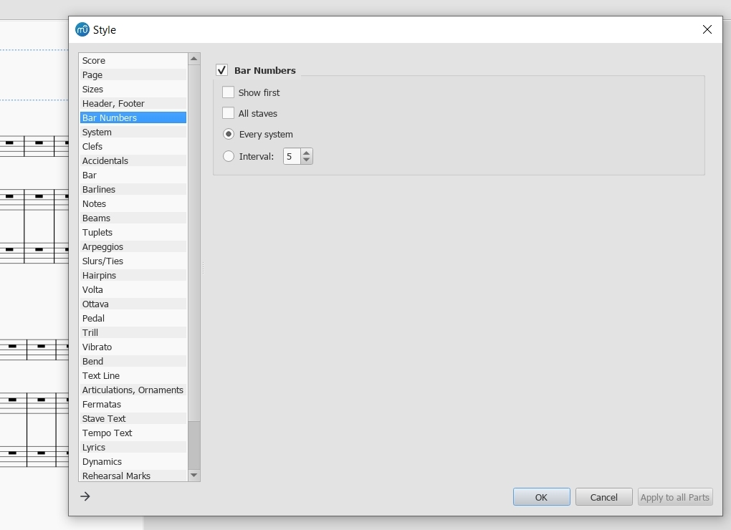
All blank, gone in one day after an “Update”?

