attempting to uninstall MuseScore 3 through Settings/Apps results ultimately in this:
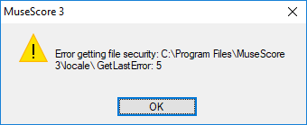
clicking OK results in rolling back the process.

Settings/Apps does not list “MuseScore3” or “NewMuseScore3.” So there is no option to uninstall those.

There are some empty folders under MuseScore 3:
Every folder and subfolder in bin is empty.
demos is empty
instruments is empty
locale and its subfolders are empty
manual/plugins contains two files: manual.css and plugins3.html.
plugins and its subfolder helloqml contain some files.
qml seems to contain a lot of files in its subfolders.
sound contains two files, MuseScore_General.sf3 and MuseScore_General-License.md.
styles, templates, tours, wallpaper, and workspaces all contain some files.

