Adagio
Second movement
from
Clarinet Concerto in A(K622)
by
W A Mozart (1756 – 1795)

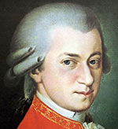

arranged for Recorders
(Treble, Tenor, Bass and Great Bass)

With the use of a free Score
for Clarinet & Piano
by Andy Ralls
from www.mfiles.co.uk

