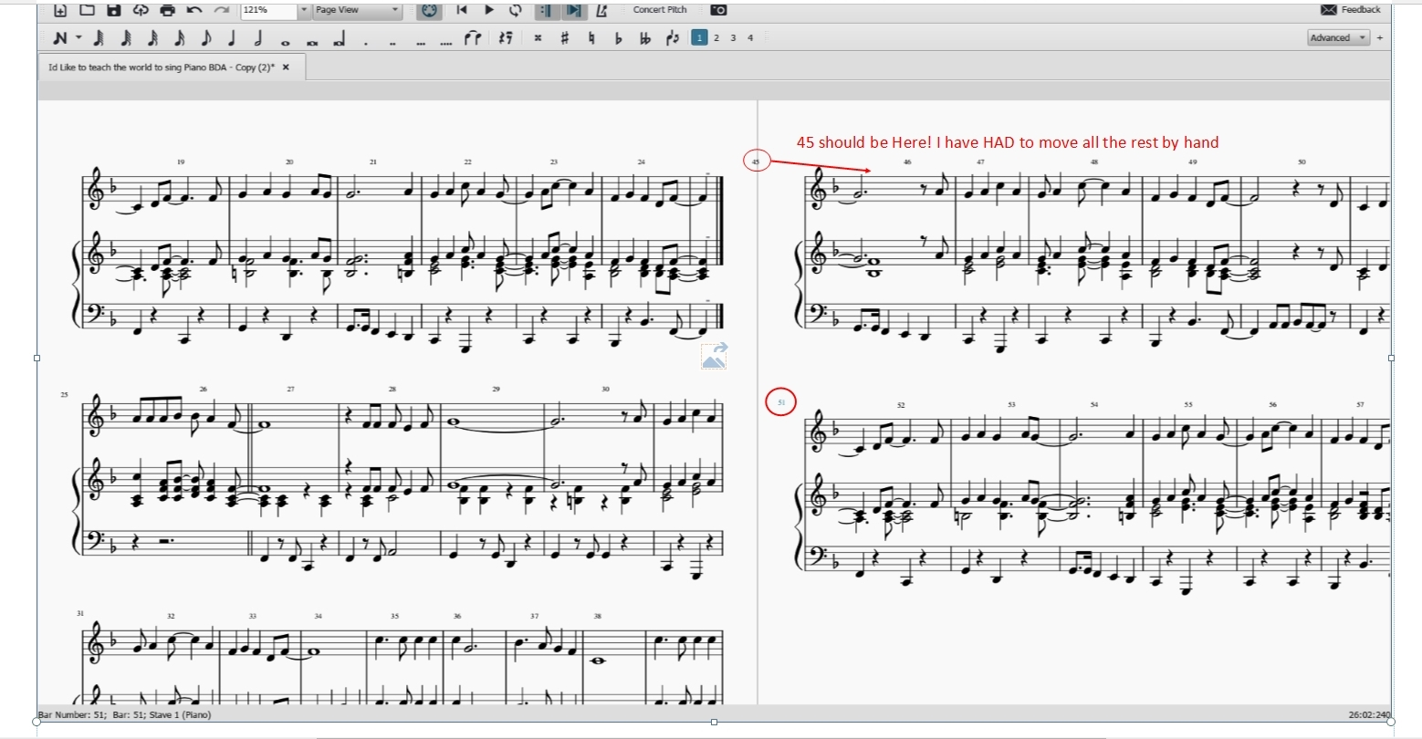
More on the bar numbering problems, sorry it’s a bit blurred but the problem is obvious. The numbers are not lining up as they are supposed to. I have used the X – Y plus or minus on the Bar numbers “Format Style” but it has never worked out? As I said previously, bar numbers are essential for practical transposition as I play clarinet?
If you can help or suggest a work around I would be very grateful
Many thanks
Barry Austin

