This file contains two instruments: a lead melody line and a bass line.  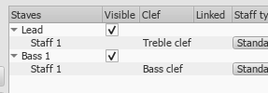 | These appear in two parts: Lead Sheet containing both lines and a Melody containing only the lead.  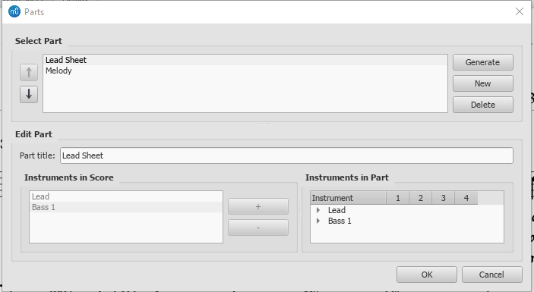

I’ve updated the lead instrument in the Lead Sheet part with FM symbol and fret diagram.  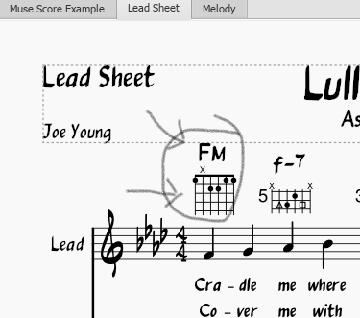 | Master Score: fret diagram has updated, but chord symbol has not.  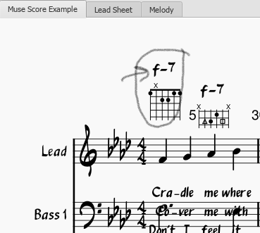 | In the Melody part itself neither the chord symbol or fret diagram reflect the changes made to the lead.  