Thanks for your help

Sorry, my question was wrong

Please explain me how to enter something like this

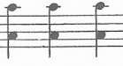

I am not very experienced with MuseScore

Thanks

Moshe