Adding Custom Instruments and Transposing Voicings

Table of Contents
Adding Custom Instruments and Transposing Voicings 1
Table of Contents 2
1 Introduction 2
2 Editing and Adding Instruments to the Configuration 2
2.1 The Instruments Configuration File 2
2.2 Applying the Changes 5
2.3 Customizing Instrument String Data 5

Introduction
I frequently encounter odd guitar related issues with MuseScore when experimenting with altered tunings. Since these use cases are by definition corner-cases MuseScore’s default behavior does not adapt well to addressing them.
While capoing-up is hardly a guitar corner case, treating this like a custom tuning will solve the problem.
Some folks on the forum seemed to ask why this use case is necessary. Well this is a very common issue. More than a simple cheat or short-cut; the capo allows the instrument to play different voicings as necessary to meet the demands of the music. E.g. Many fiddle tunes in the key of A just sound better on guitar out of standard tuning capoed up a whole step. The G-run is just a staple of the Bluegrass sound.
Tell MuseScore to transpose the guitar part up a whole step via its Custom Instruments configuration.

Summary of steps required transposing capoed guitar parts
- Configure a custom instruments file.
  - Copy the default instruments.xml to the local user MuseScore folder.
  - Remove all the default instruments to avoid any name conflicts.
  - Use the default instruments as templates for creating new custom instruments.
- Tell MuseScore to load instruments from the custom instruments XML config file.
  - Edit :: Preferences.
  - Select the Score tab.
  - Use the file browser to load the new file.
  - Note: MuseScore automatically refreshes its instruments list when the preferences update.
MuseScore may be forced to refresh by re-loading this file.
This is necessary after modifying the file.
- Create a copy of the default guitar instrument and transpose it up to the desired capo position.
  - Copy the default guitar instrument.
  - Give it a unique instrument id name.
  - Add the transposeChromatic attribute and give the value equivalent to the number of frets capoed.
- Create a new score and add the newly created custom instrument to the piece.

Editing and Adding Instruments to the Configuration
Reference https://musescore.org/en/node/15803

The Instruments Configuration File
Musescore defines its instruments in a default config file. Merge additional instruments into the default configuration via a secondary file. This preserves all the default settings deployed with the package while providing the flexibility to define custom instruments.
Musescore defined its instrument configuration via Edit :: Preferences :: Score :: Instruments List.
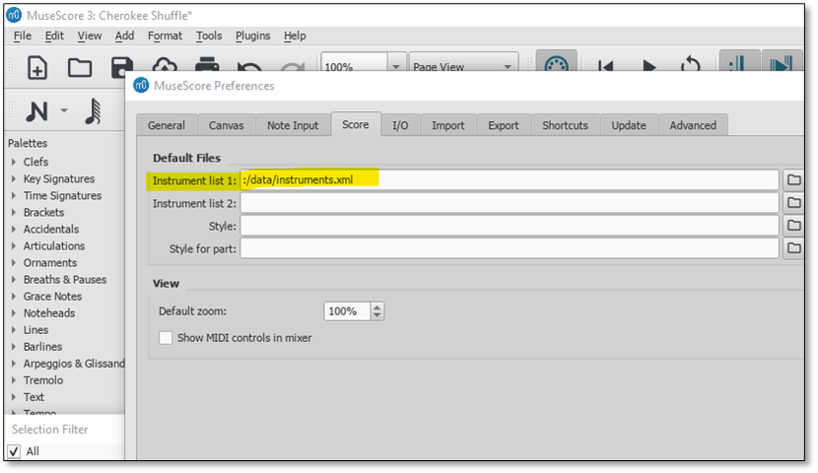

The default instrument config file is :/data/instruments.xml.
The default path points to the instruments folder under the Musescore installation directory.
E.g. C:/Program Files/MuseScore 3/instruments/

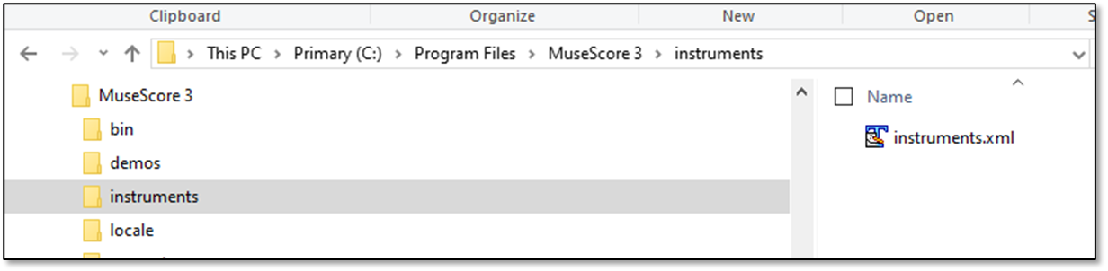

side-bar
The developers have actually obscured this a bit.
I would have expected the :data variable to point to a general data folder, but it seems like it may reference different folders depending upon its context.
E.g. :data for instruments points to the <install dir>/instruments.
But styles points to the <install dir>/styles.

I would have done this differently. I would have created an <install dir>/data folder, then put each of the different configuration folders under that (or maybe just placed all of the XML files directly into the data folder. I mean, really, does each XML file need its own directory?)

Create a new file that will only contain the customizations.
Place the file in the Musescore Documents directory with other local customizations. (This should prevent overwriting of any customizations during any application updates.)
C:\Users\<useraccount>\Documents\MuseScore3\Instruments\custom_instruments.xml
Put this path into the Instrument List 2 configuration parameter.
Access this dialog via Edit :: Preferences. Select the Score tab.
Note: the path this image points to the application directory instead of the documents directory.
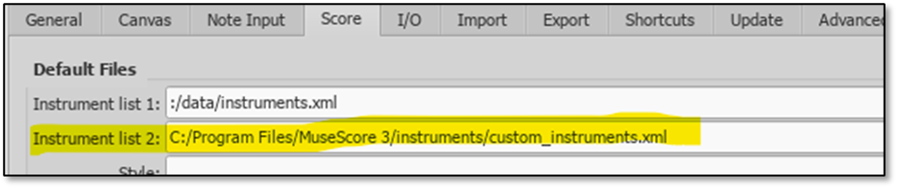
Reference the original instruments.xml file to find the necessary XML options required for creating the necessary customizations.
The following example creates a new category or genre for local custom instruments, then adds two POC instruments to the configuration under the Plucked String InstrumentGroup.
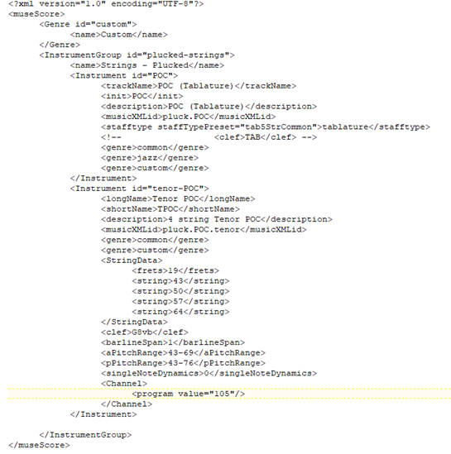

Applying the Changes
Two methods of refreshing the instruments list
- Restarting Musescore refresh and apply the changes.
- Alternately re-loading the file via Edit :: Preferences :: Scores (tab) will refresh the instruments. You will probably have to create a dummy file. Load that, then revert back to the updated instruments file.

Customizing Instrument String Data
Probably the primary reason for creating a custom instrument is to customize the string configuration.
Instruments.xml defines this via the StringData element.
The string elements define the string pitches. The number of string elements defined for a StringData element determines the number of strings for the instrument.
The pitches correspond to Midi pitches.
(Reference https://newt.phys.unsw.edu.au/jw/notes.html and https://en.wikipedia.org/wiki/Scientific_pitch_notation)
Note: the table below highlights middle-C in blue and A440 in yellow.
Fundamental frequency in hertz (MIDI note number)
Octave  Note | −1 | 0 | 1 | 2 | 3 | 4 | 5 | 6 | 7 | 8 | 9 | 10
C | 8.1758 (0) | 16.352 (12) | 32.703 (24) | 65.406 (36) | 130.81 (48) | 261.63 (60) | 523.25 (72) | 1046.5 (84) | 2093.0 (96) | 4186.0 (108) | 8372.0 (120) | 16744 ()
C♯/D♭ | 8.6620 (1) | 17.324 (13) | 34.648 (25) | 69.296 (37) | 138.59 (49) | 277.18 (61) | 554.37 (73) | 1108.7 (85) | 2217.5 (97) | 4434.9 (109) | 8869.8 (121) | 17740 ()
D | 9.1770 (2) | 18.354 (14) | 36.708 (26) | 73.416 (38) | 146.83 (50) | 293.66 (62) | 587.33 (74) | 1174.7 (86) | 2349.3 (98) | 4698.6 (110) | 9397.3 (122) | 18795 ()
E♭/D♯ | 9.7227 (3) | 19.445 (15) | 38.891 (27) | 77.782 (39) | 155.56 (51) | 311.13 (63) | 622.25 (75) | 1244.5 (87) | 2489.0 (99) | 4978.0 (111) | 9956.1 (123) | 19912 ()
E | 10.301 (4) | 20.602 (16) | 41.203 (28) | 82.407 (40) | 164.81 (52) | 329.63 (64) | 659.26 (76) | 1318.5 (88) | 2637.0 (100) | 5274.0 (112) | 10548 (124) | 21096 ()
F | 10.914 (5) | 21.827 (17) | 43.654 (29) | 87.307 (41) | 174.61 (53) | 349.23 (65) | 698.46 (77) | 1396.9 (89) | 2793.8 (101) | 5587.7 (113) | 11175 (125) | 22351 ()
F♯/G♭ | 11.563 (6) | 23.125 (18) | 46.249 (30) | 92.499 (42) | 185.00 (54) | 369.99 (66) | 739.99 (78) | 1480.0 (90) | 2960.0 (102) | 5919.9 (114) | 11840 (126) | 23680 ()
G | 12.250 (7) | 24.500 (19) | 48.999 (31) | 97.999 (43) | 196.00 (55) | 392.00 (67) | 783.99 (79) | 1568.0 (91) | 3136.0 (103) | 6271.9 (115) | 12544 (127) | 25088 ()
A♭/G♯ | 12.979 (8) | 25.957 (20) | 51.913 (32) | 103.83 (44) | 207.65 (56) | 415.30 (68) | 830.61 (80) | 1661.2 (92) | 3322.4 (104) | 6644.9 (116) | 13290 () | 26580 ()
A | 13.750 (9) | 27.500 (21) | 55.000 (33) | 110.00 (45) | 220.00 (57) | 440.00 (69) | 880.00 (81) | 1760.0 (93) | 3520.0 (105) | 7040.0 (117) | 14080 () | 28160 ()
B♭/A♯ | 14.568 (10) | 29.135 (22) | 58.270 (34) | 116.54 (46) | 233.08 (58) | 466.16 (70) | 932.33 (82) | 1864.7 (94) | 3729.3 (106) | 7458.6 (118) | 14917 () | 29834 ()
B | 15.434 (11) | 30.868 (23) | 61.735 (35) | 123.47 (47) | 246.94 (59) | 493.88 (71) | 987.77 (83) | 1975.5 (95) | 3951.1 (107) | 7902.1 (119) | 15804 () | 31609 ()

Transposing the pitches played by the instruments
To transpose the pitches played by the instrument, define the transpose XML elements in the Instrument configuration.
This applies to arranging music for transposing instruments like the clarinet or for arranging music for a capoed guitar. (Note: reference the original Clarinet instrument in the MuseScore application instruments.xml file.)
Open the instruments XML configuration and either edit an existing instrument or create a new one.
In either case add the following two XML elements to the Instrument configuration.
Note: Actually, MuseScore only requires the transposeChromatic entry.
<transposeDiatonic>1</transposeDiatonic>
<transposeChromatic>2</transposeChromatic>
E.g. the following guitar instrument has been configured to render the Musescore part in C, but play in D.

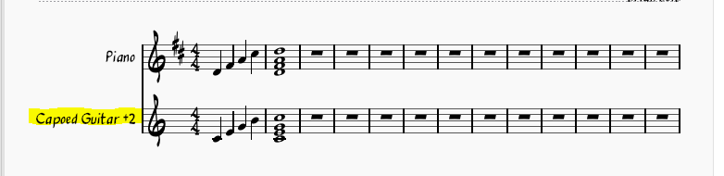

The instruments XML config file contains the following entry.
A CapoedGuitar instrument has been defined within an optional new custom InstrumentGroup name CapoedInstruments.
It has been transposed (capoed) up two half-steps via the transposedChromatic configuration.

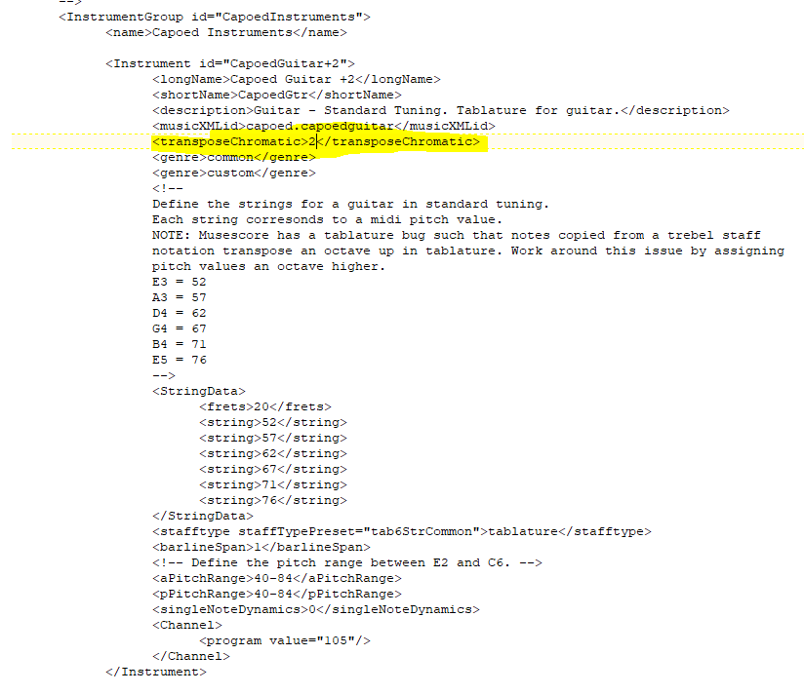

Troubleshooting

Proof the XML file
Your instruments will not appear if MuseScore cannot load the XML.
MuseScore will not throw any errors or provide any feedback. It just will not load the invalid XML file.
Verify the XML using any available only XML lint (syntax checker) tool.
E.g. https://www.freeformatter.com/xml-formatter.html

Custom instruments do not appear in the instruments list
- If MuseScore fails to load the custom instruments XML file then they will not appear in the list. See the section above concerning proofing XML.
- The file path is misspelled in the preferences dialog. Use the file browser to make sure the preferences reference the correct path.
- Custom instruments do not have unique instrument IDs. MuseScore requires that each instrument have a unique instrument id attribute. E.g. <Instrument id="CapoedGuitar+2">.

