Hello, Development Teamsters, hello, David,
The data files of the "Bagpipe Music Writer" are according to the online manual compatible with MuseScore, the manual said; MuseScore can import them, see original quote from the online manual
Bagpipe Music Writer (*.bww) (import only)
BWW files are created by the niche score writer, Bagpipe Music Writer.
(https://musescore.org/en/handbook/file-formats#bagpipe-music-writer)
How to get information on the Internet when searching for "Bagpipe Music Writer“
(https://robertmacneilmusicworks.com/home/ https://robertmacneilmusicworks.com/books-in-bmw/ https://robertmacneilmusicworks.com/product-features/)
the editor of the Musescore manual or the programmer has sat on false information. The Bagpipe Music Writer file format is marked with the suffix ".BMW" (not: .BWW)
This error has consequences. On the search for bagpipe melodies in Public Domain) I found
http://www.mohr.nu/Peter/tunes/tunes.html ' Source for some Bagpipe-Music
offers: Download a zip with the all the tunes! (app. 1689 tunes / 671 KB)
Orginal-Quote:
The BMW-Tunes Page
The tunes listed here on this page can be printed, played and viewed on a PC with a program called "Bagpipe Music Writer" which can be obtained from Robert MacNeills Musicworks
I have downloaded and unzipped this ZIP file. Result: I now have 1689 Jigs, Reels, Airs, Marches and Strathsprays in the format ".BMW" as files on the harddisk - and Musescore can't read any of them! The attempt ends always here (=> Type unknown):
Musescore: Loading error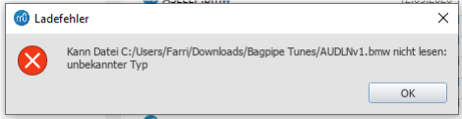
Now, as a user with 40 years of experience since 1980 (the first own: C=64 was 1983) I am not easily impressed. I'll just try to change the file suffix from correct to wrong (on a copy of the file, Robert Burns' "Auld Lang Syne", well known!)
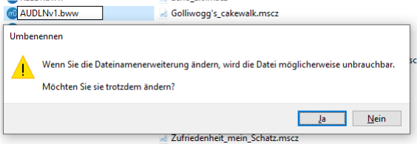
You can ignore this warning of the OS (only a copy, no original).
The file then appears as
in the directory. And to big surprise: The error is not only in the manual, but also inside the source code of Musescore 3, because now Musescore can load and play the file now.
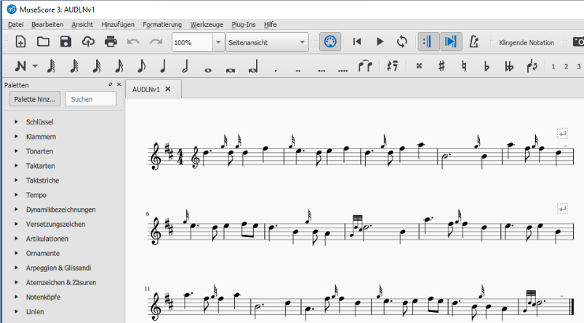Now you might ask: If the FarrierPete has already found the WorkAround - what more does he want?
Yes, MS 3 loads and plays that. BUT: the bug from 2015 that occurred with the predecessor MS 2.02 - that's back. Musescore can't get the timing of the "Embellishments" (= Acciacatura) right, looses beat and tempo and stumbles through the score again.

