Input .musicxml file:
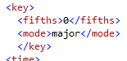

Exported .musicxml file from MuseScore:
