Problem in MuseScore with ABC Import Plugin
This is the second time I report this problem. I used a workaround but the problem is now all the time. I copy / paste ABC code from TheSession.org: example
https://thesession.org/tunes/449

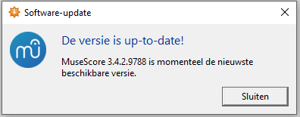

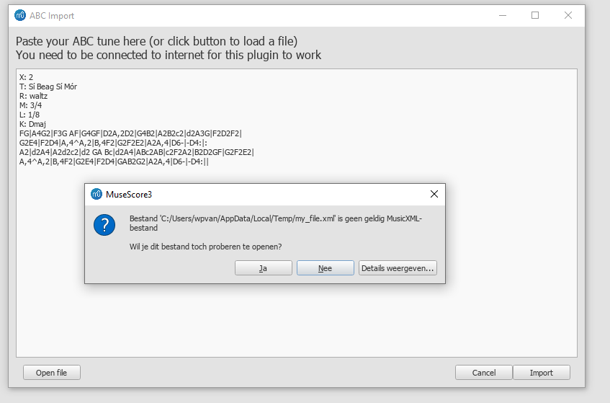
Clicking Ja returns an Empty My_Fyle
Clicking Nee aborts
This is now happening all the time. Using this function is important to me.
Regards,

Willem van Loenen

