Apparent problems with Hebrew on Musescore

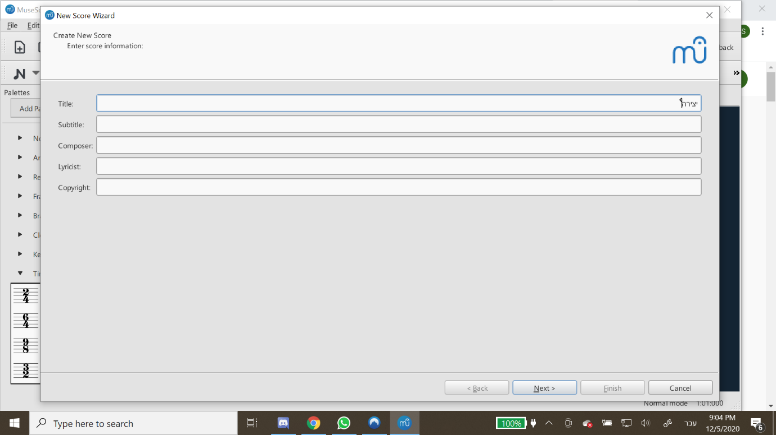
Weird looking typing pointer on the new Score Wizard (and other places in which you might want to type in Hebrew such as instrument name.

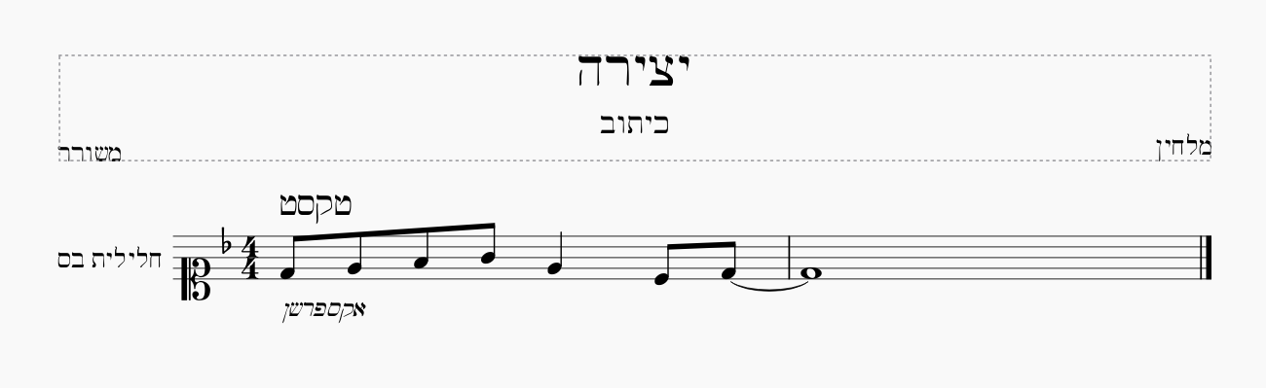
Very ugly default font on the page

Additionally, some keyboard functions do not work while the keyboard language is set to Hebrew, such is letter note input and ctrl shortcuts.

