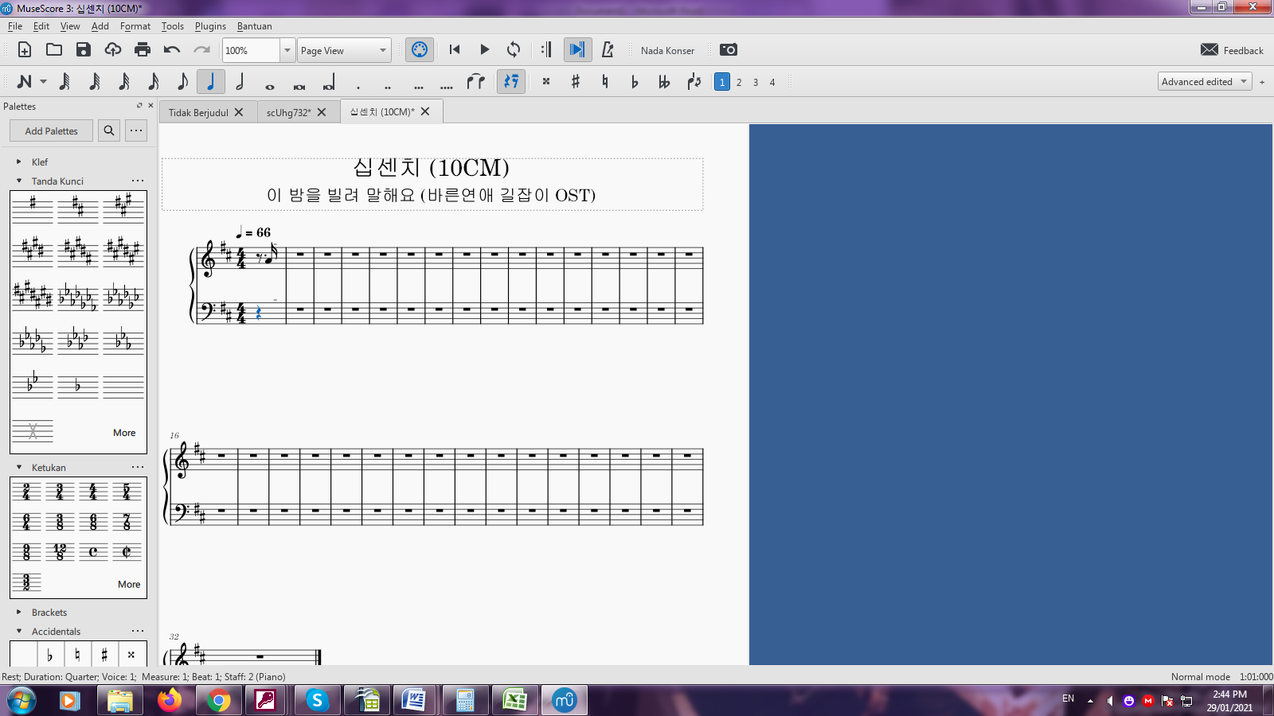

HOW TO CHANGE THE REST BECOME A WHOLE REST ??
IS THERE ANYONE KNOW ABOUT THAT? PLEASE HELP ME

