Starting Point:
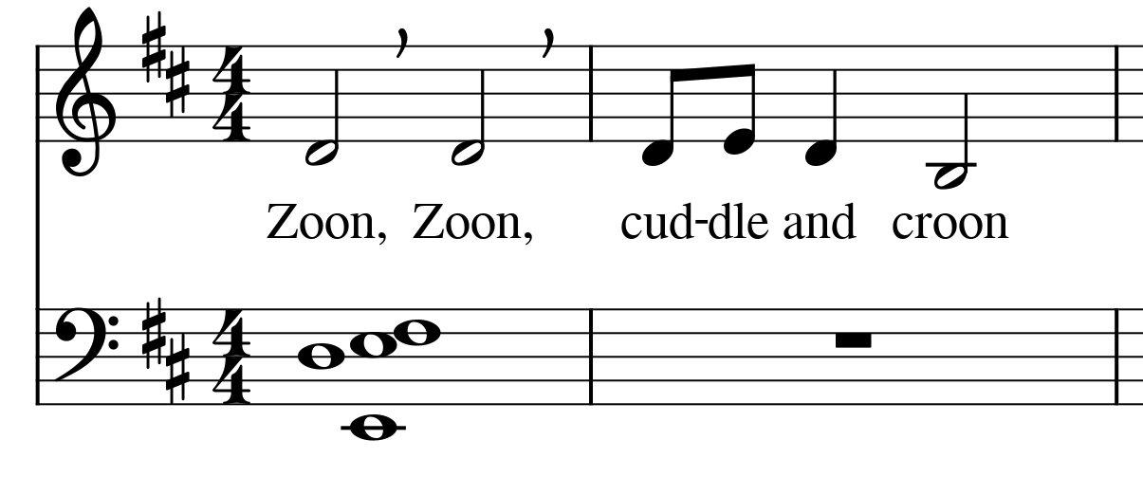
Attempting to use note entry mode to add a half note G on the bass clef staff to score results in:
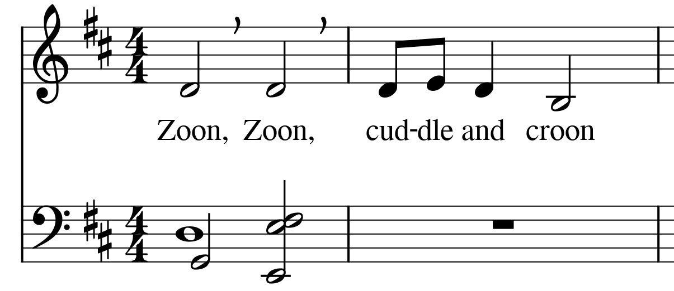
The half note is added as desired, but 3 existing whole notes have been converted to half notes which was not wanted. Also both E's and the F were moved from beat 1 to beat 3.
Attempting to change the higher E to the original whole note gives us:
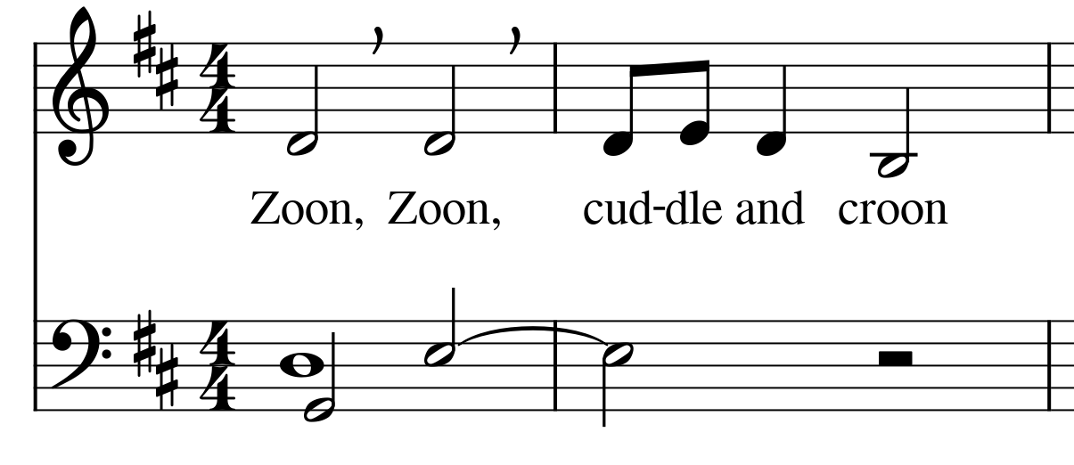
[The image capture from MuseScore did not properly copy to this document, but all the notes are present.] The E properly converted to 4 beats, but the lower E and the F have now disappeared.

Going back to square one:
Selecting the higher E and attempting to change it to a half note results in:
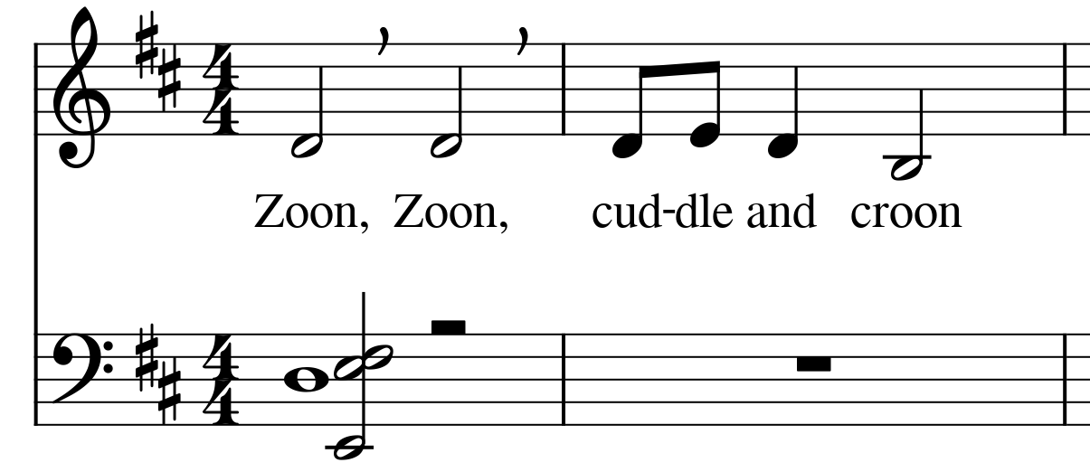
The E is changed to a half note, but so are the lower E and the F.
From the starting point again:

Selecting the D, higher E, and F and attempting to convert to half notes results in:
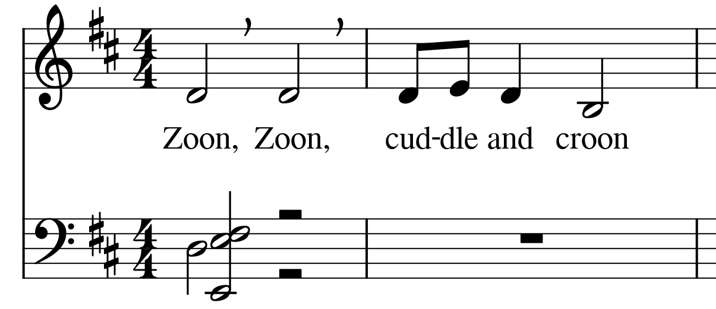
The lower E is also converted to a half note.
Selecting the lower E and converting it to a whole note results in:
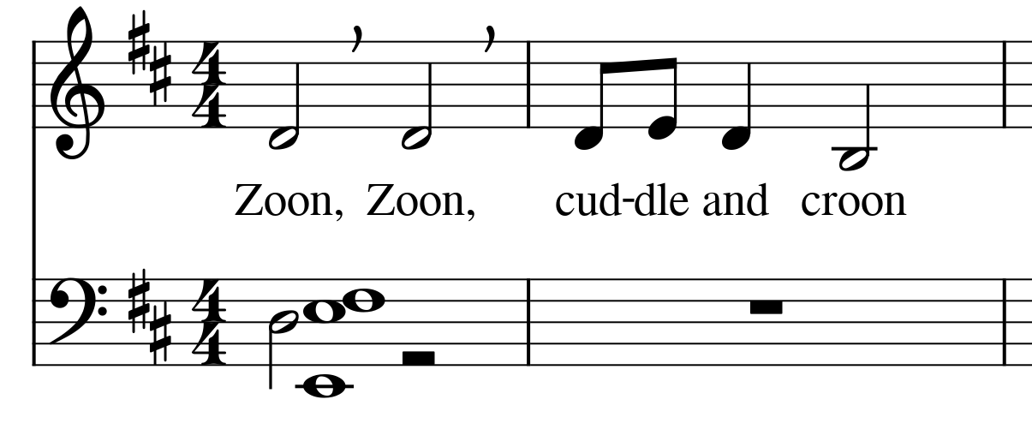
Both E's and the F are now whole notes.

How do you seperate the two E notes so that one can be a half note while the other is a whole note?

