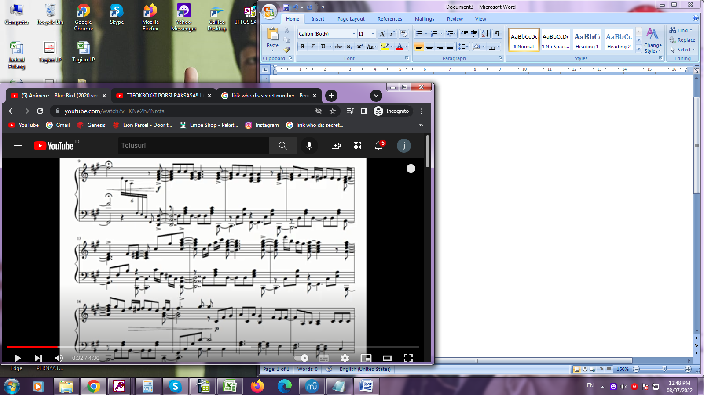
QUESTION : FOCUS ON BAR 9 AFTER F# NOTE WITH FERMATA ABOVE HOW TO CONNECT THE NOTE BETWEEN THE TREBLE CLEFF AND BLASS CLEF

