yes, presently measures 39 to 44 are on the same line.. but if i try to drag the pitch of the notes on the 3rd part in measure 44 down to A the measure length changes. This puts measure 44 on the next line. there is a line feed on measure 44 so measure 44 becomes very stretched and its own line.
See below re-enactments...

Prior to moving pitch of line 3:
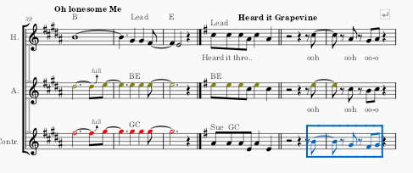

After moving pitch in line 3 measure 44 from B to A:
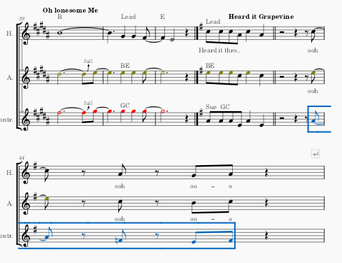

Measure 44 is now in its own line.

