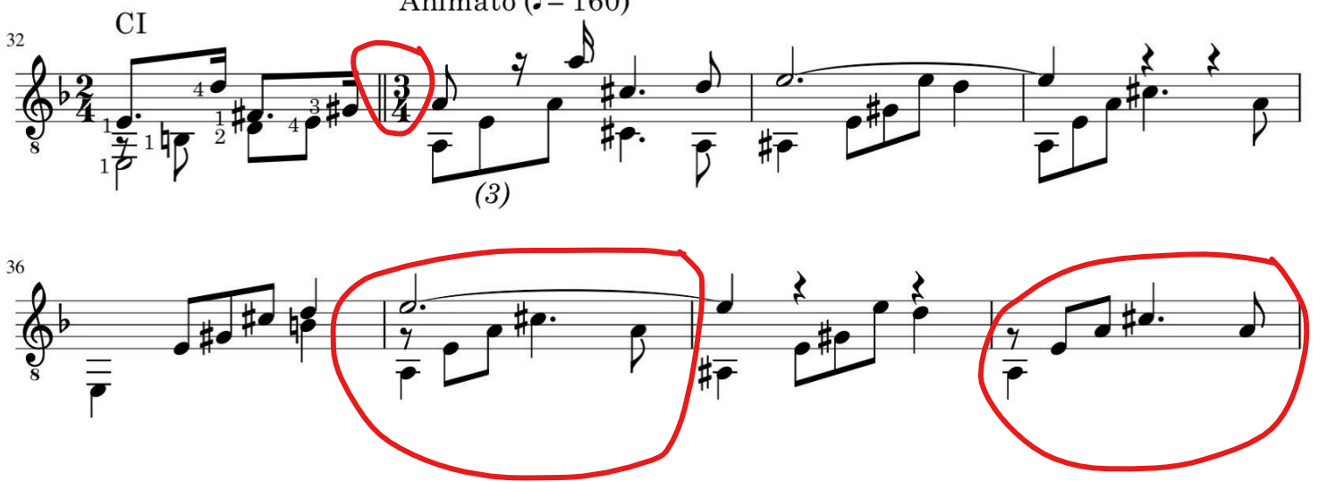
I cannot work out voices for bar 37 and 39. However, I could delete the rest, and group C# and A to a triplets, that will resolve the second voice for both bars however, I don’t know how to input a different notes in a triplets here I need C# and A. could you help?

