Mozart Oboe quartet K370, Rondo - 2
kostenkovd bars 518-32, in 3/8
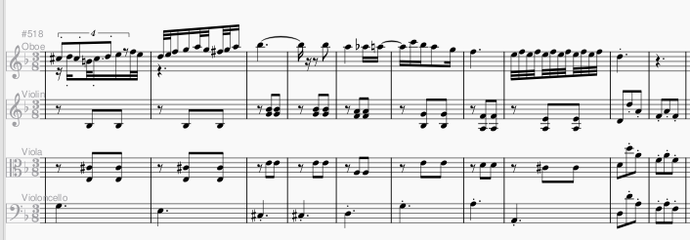
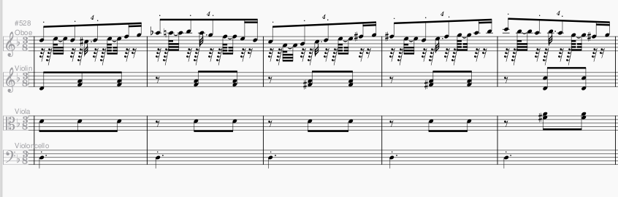
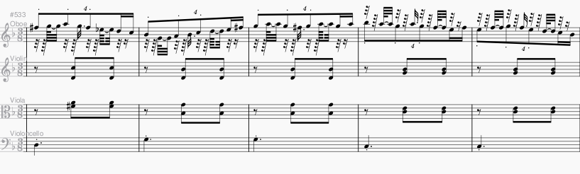
Original bars 98-107, with oboe in 4/4 and strings in 6/8
