MuseScore note and location

Hello,
I encounter a problem with MuseScore 4.0.2:

As shown below, the 3 curves are ties (not slur), the first, second, and 7th eighth notes are all "F", but the first and the 7th eighth notes are placed in the wrong location of "G" (all the 3 notes are "Fa" sound). The quarter note and the whole note are "G".

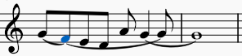

What causes the problem? How to solve the problem?

Thanks,

Yanmin Wang
yanminwang2002@yahoo.com

