The soprano, tenor and alto parts show like this:

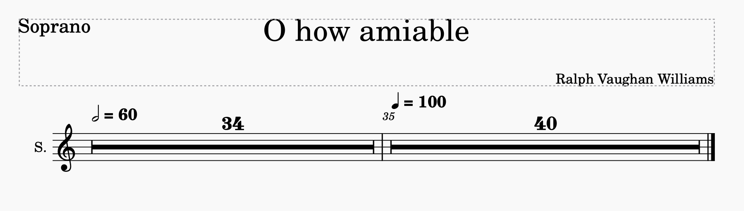

The bass is the only part that is showing correctly:

