File when first opened
Correct key signatures for transposing instruments
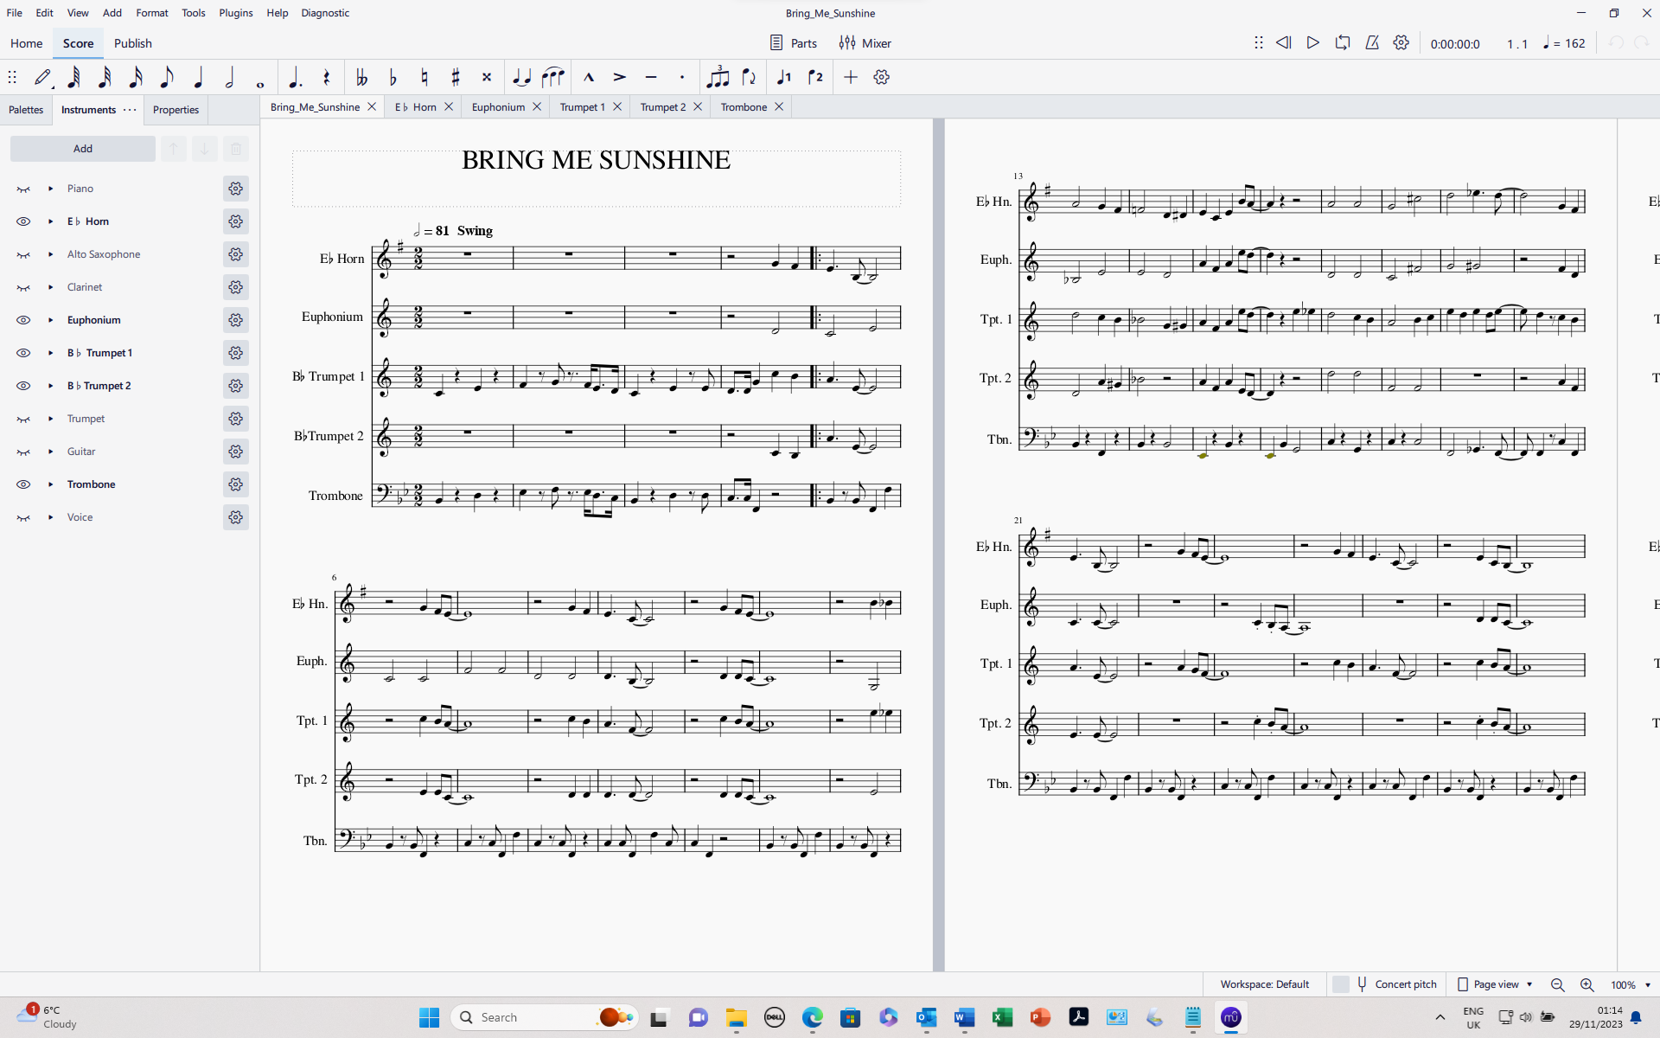
Turn on concert pitch view
All instruments showing the key of B flat

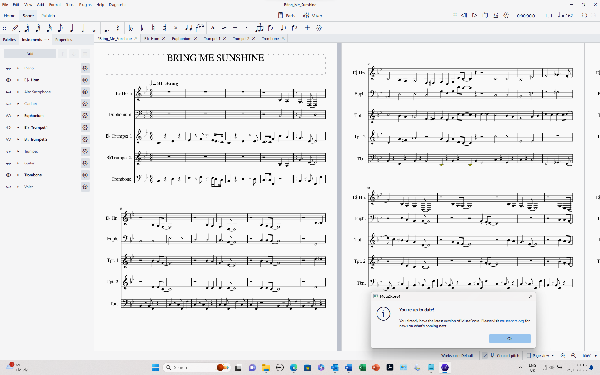
Turn off concert pitch view
Wrong key signatures after first line, but correct notes.

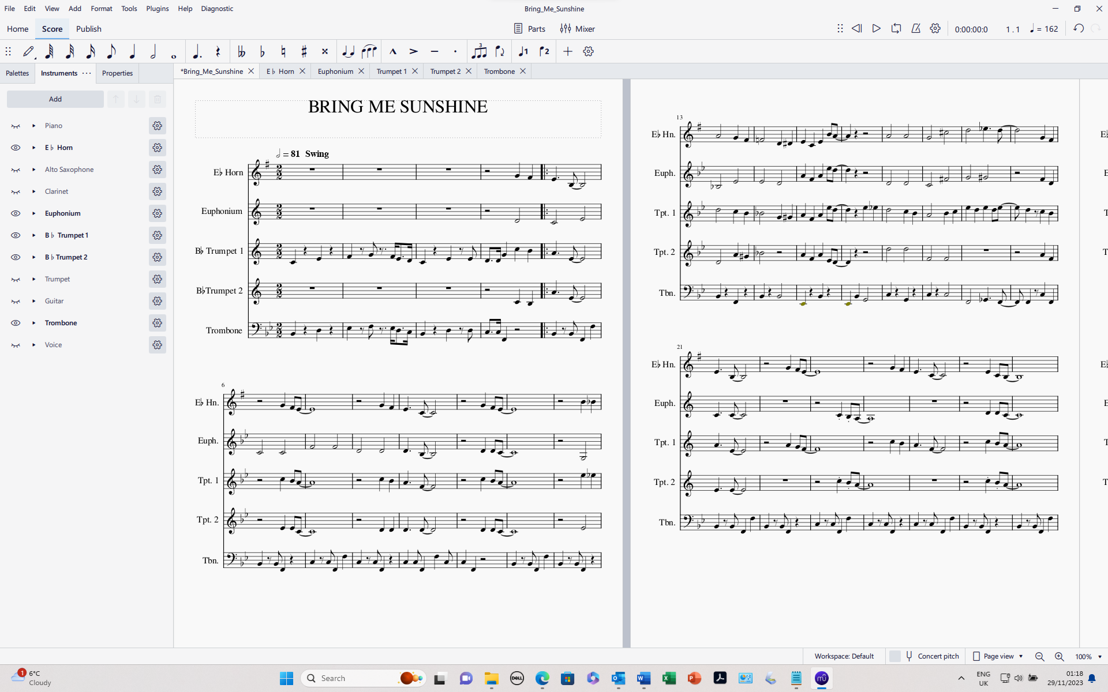
Concert pitch view showing the hidden instruments too.
They are all shown in the key of B flat
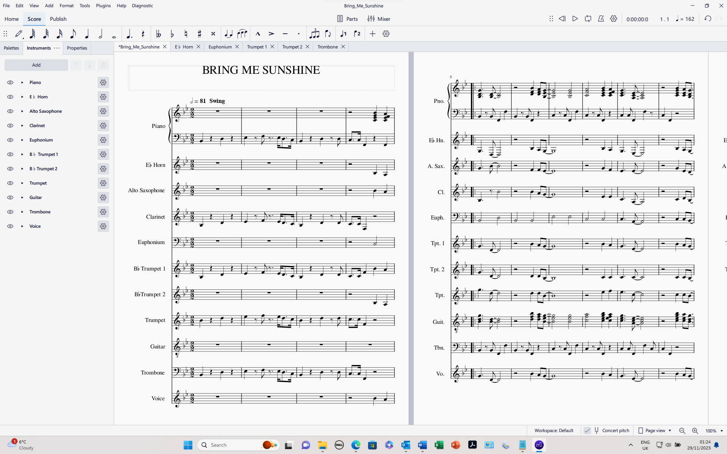
Turn off concert pitch view
Wrong key signatures but correct notes on page 2
