MuseScore Lute Tab

(1) Method 1 (MS3)

Here’s what the score looks like (Lute (Tablature)):
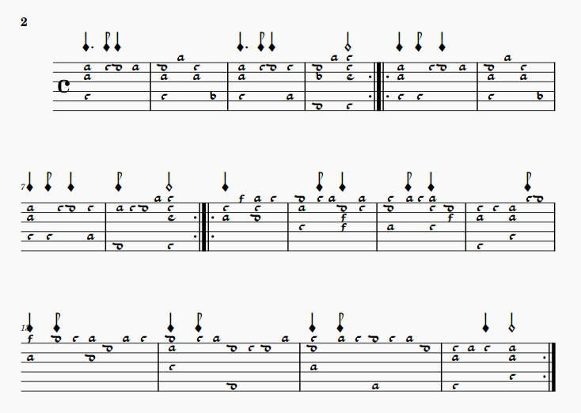
After clicking on “Edit String Data”
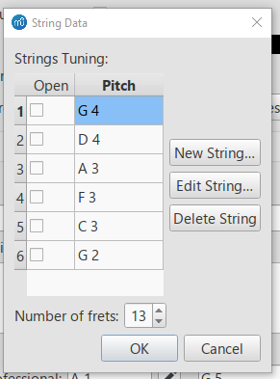
I then click on New String and chose F2:
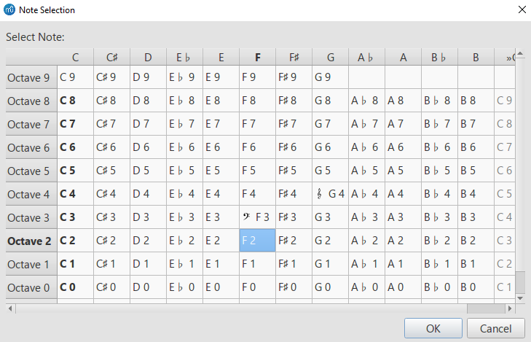
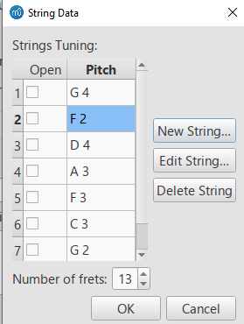
But F2 is the second string, and it should be the 7th.
Score now looks like this:
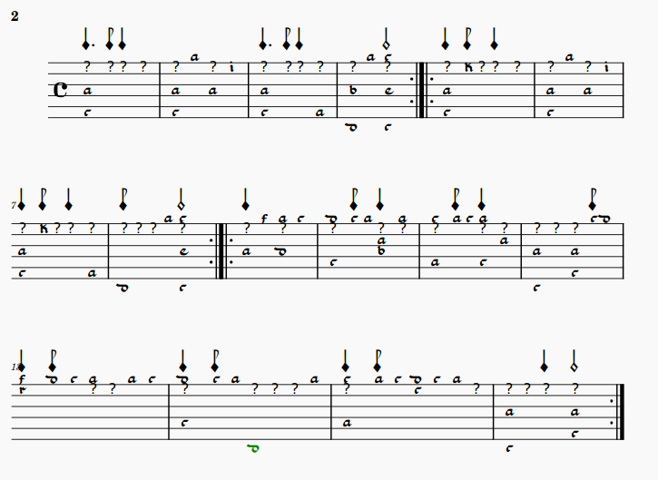
The second string is now not D4 as it ought to be, but F2. And apart from String 1 (which is G4 as it is meant to be), every other string is now wrong (see the snip above of the string data dialogue box after adding the new string).
This is why I tried editing the strings, to get them in the right order:
String 1 = G4
String 2 = D4
String 3 = A 3
String 4 = F3
String 5 = C3
String 6 = G2
String 7 = F2

But this is what happens when I click on string 2 to change it from F2 to D4:
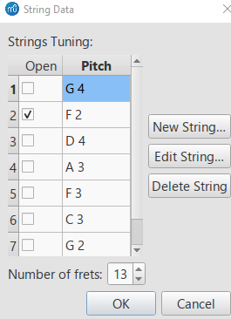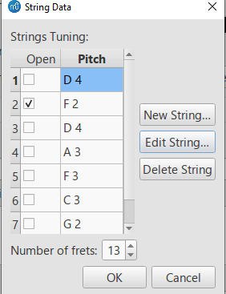
It changes String 1 from G4 to D4, String 2 remains as F2, and I can’t get any further than this.
There is no means that I can see of reordering the way the strings default to make F2 be string 7, and keep the other 6 in their proper order.
I tried working up from String 7, but the same problem occurs.
(2) Template
I downloaded the MS4 template you provided, and it seems that the same thing is happening here too.
This is what the template looks like – and despite it showing 6 lines but being for 7 strings (as I was hoping for, so the notes for the 7th string would be below the stave), I can only input notes as if it were standard 6-course French lute tab, and String 2 is F2, rather than the new string at F2 being String 7:
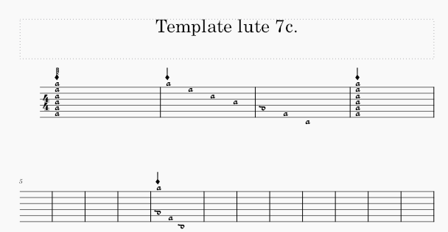

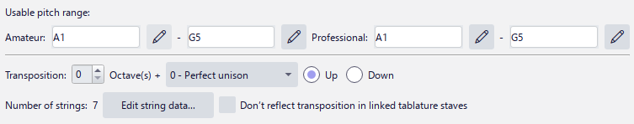

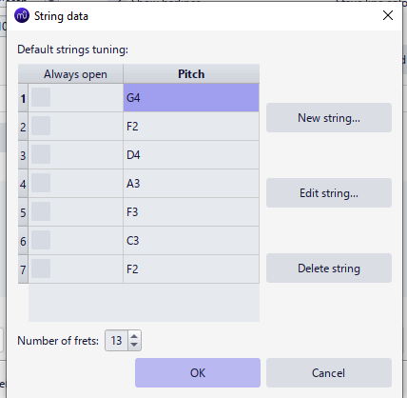
Maybe I am doing something wrong? as the template clearly shows a note below the stave. I can copy each bar, and then change the notes (as per bar 9 in the above example) – this is the only way I can see to get the note to input below the stave. But this does not solve the problem of string 2 being F2 instead of D4, and all the other strings from 3-7 being incorrect as a result.
(3) Method 2 MS3
Firstly, I went into Stave/Part Properties, and changed the instrument to Lute 7-course.

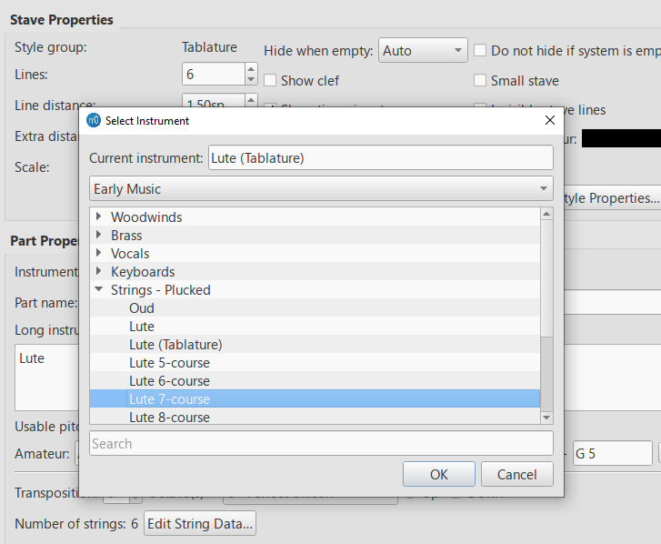
This doesn’t give the option to change the stave type, though, which results in the score now looking like this:
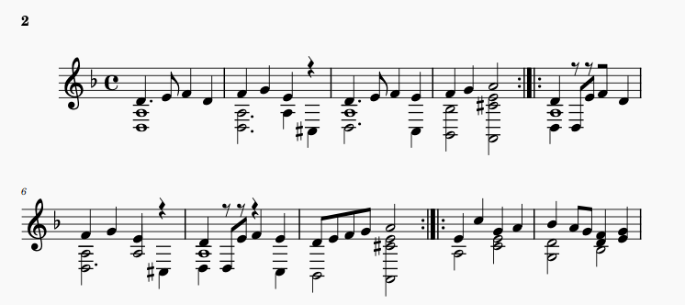
I cancelled those changes and tried to change the instrument (using either I or Edit>Instruments, as for some reason F7 doesn’t work for me)I get this:
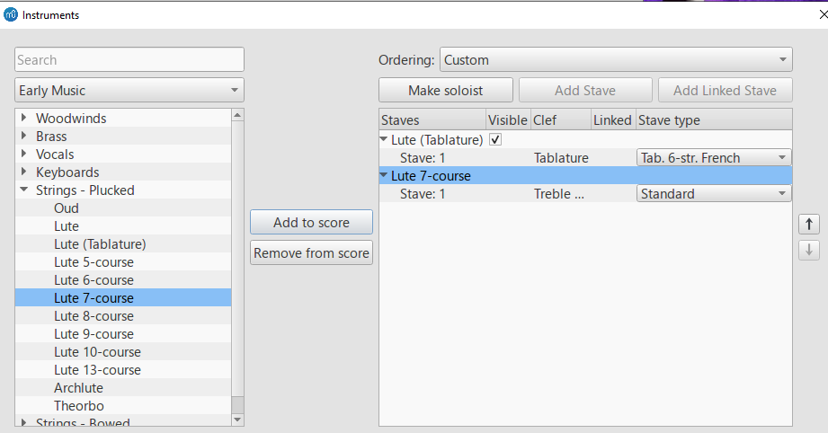

So I then removed the Lute (Tablature) i.e., Tab 6-str. French from the instruments, leaving me with Lute 7-course and Stave = Standard. I then opened the Stave Type drop-down menu (which cannot be snipped or copied because it is a drop-down, an unfortunate problem common to all drop-down menus) – these are the options:
Standard
Tab 6-str simple
Tab 6-str common
Tab 6-str full
Tab 4-str simple
Tab 4-str common
Tab 4-str full
Tab 5-str simple
Tab 5-str common
Tab 5-str full
Tab ukelele
Tab balalaika
Tab dulcimer
Tab 6-str Italian
Tab 6-str French
Tab 7-str common
Custom Standard
Custom Percussion
Custom Tablature

Tab 7-str common appears to be Italian tab - the score came up like this, although it was blank so I had to input notes:

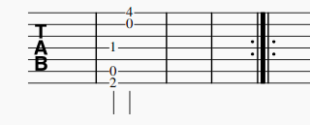

The only other option I could see that might be applicable is Custom Tablature, but that gives this (again, the score came up as blank, and I had to input notes):
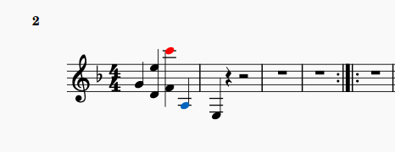
I really don’t know how I would change the stave to French tab.

