Divisi arrows are beyond RH margin of bars.
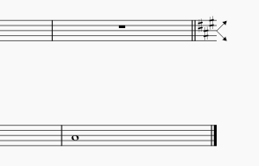
Entering a break at end bar creates courtesy accidentals, as expected.
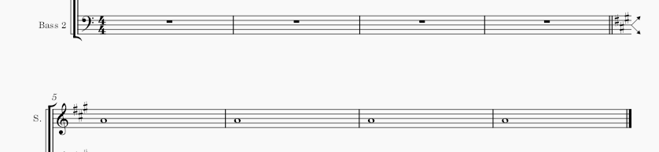
Suppose we want the divisi arrows to end at the same right hand margin as the rest of the bars?
Instead of entering a system break, inserting a horizontal frame at bar 5 and entering a break at that frame breaks the stave all right but now there are no courtesy accidentals
