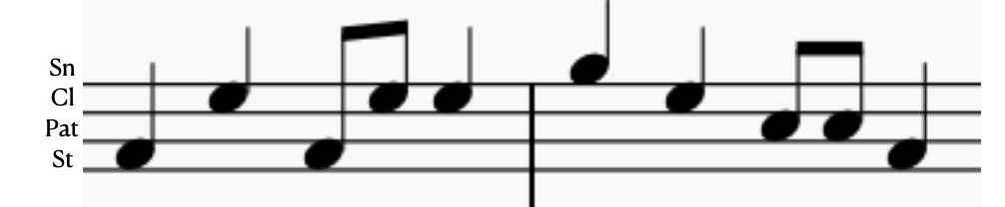

I would prefer line notes, but this is the basic score order from low stamp, up to leg pat, up to clap, up to snap.

