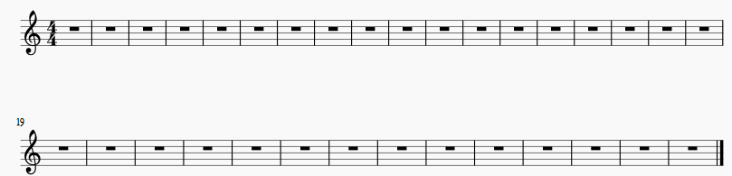
When I filled at MuseScore wizard 50 measures,I received 2 staffs above.
My question is how add extra 2 and more as shown below.
Please inform how MuseScore can help in this case.
End bar lines should be same as at the first staff above and as usually the last one should be as last shown above.

