Your message:
- check to see if it still works: https://musescore.org/en/node/21495 [1] works good.
- Edit/Tools...->Add/Remove line Breaks Please see picture 2 that I have,after I click O.K.
- Right-click –(Please inform where I should make a Right –click)> Add -> Text ? I click on a note and I can type under note that I clicked but not where I want (Picture 1).
As I understand I click wrong place,please make clear.
I need type the text that I showed by red color concerning Style,Voice and Tempo (Picture 1).
Picture 1
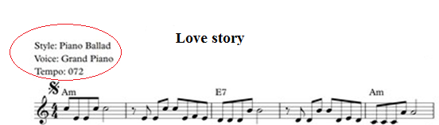
Picture 2

