MuseScore

Free music composition & notation software
EASY to use - BEAUTIFUL scores - FREE

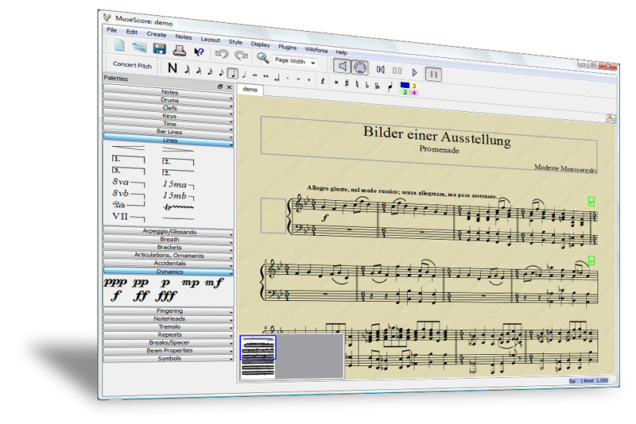

Download for free www.musescore.org

Features

e Notes are entered on a "virtual note sheet"
e Easy and fast note entry with mouse, keyboard or MIDI
e Unlimited number of staves, up to four voices per staff
e Integrated sequencer and software synthesizer
e SoundFont® support
e Import and export of MusicXML and MIDI Files
e Available in English, German, French, Dutch and 12 more

MuseScore

www.musescore.org

120.000
downloads and counting

Requirements

Windows, MacOSX, Linux
50MB RAM
Run on most CPUs
80MB free disk space
Follow

Twitter
twitter.com/musescore
Facebook
musescore.org/facebook
Newsletter
musescore.org/newsletter
Support

Forum
musescore.org/forum
Handbooks in 7 languages
musescore.org/en/handbook
Download this leaflet on http://musescore.org/promo and spread the word!

