MuseScore

Free music composition & notation software
EASY to use - BEAUTIFUL scores - FREE

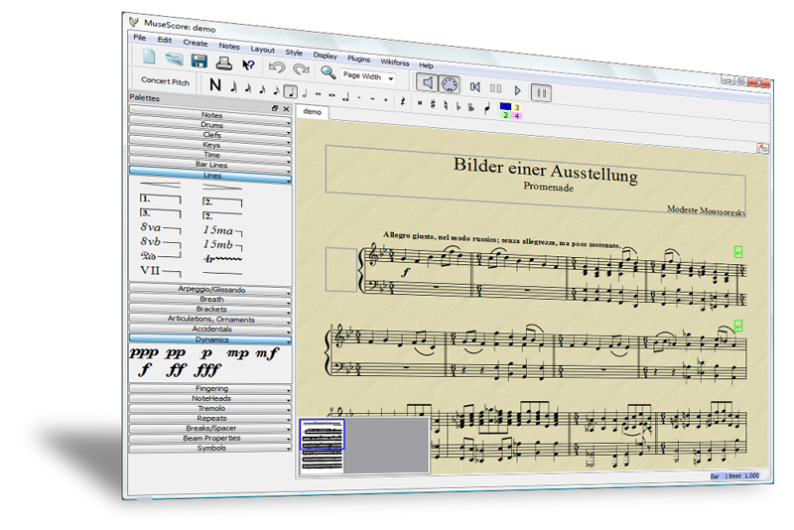

Download for free www.musescore.org

Features

e Notes are entered on a "virtual note sheet"
e Easy and fast note entry with mouse, keyboard or MIDI
e Unlimited number of staves, up to four voices per staff
e Integrated sequencer and software synthesizer
e SoundFont® support
e Import and export of MusicXML and MIDI Files
e Available in English, German, French, Dutch and 12 more

MuseScore

www.musescore.org

120 000
downloads and counting
Requirements

● Windows, Mac, Linux
● 50 MB RAM
● 133 MB free disk space
● 1024 by 768 pixels or higher
Follow

● Twitter
www.twitter.com/musescore
● Facebook
www.musescore.org/facebook
Support

● Handbook in 7 languages
www.musescore.org/en/handbook
● Forum
www.musescore.org/forum
Download this leaflet on http://musescore.org/promo and spread the word!

