Double click on the bracket, and drag the bottom point
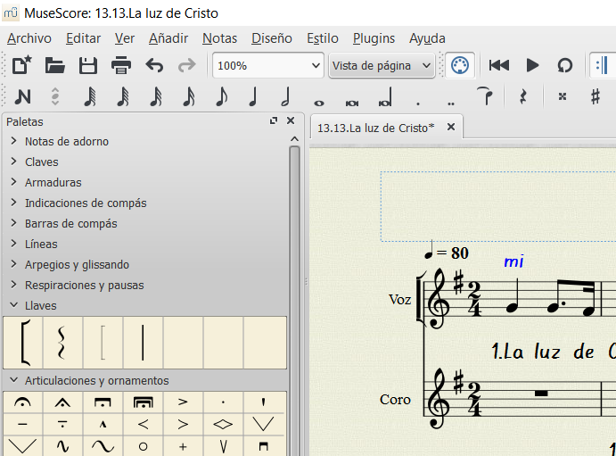
I wear bracket until the end of the system ... and
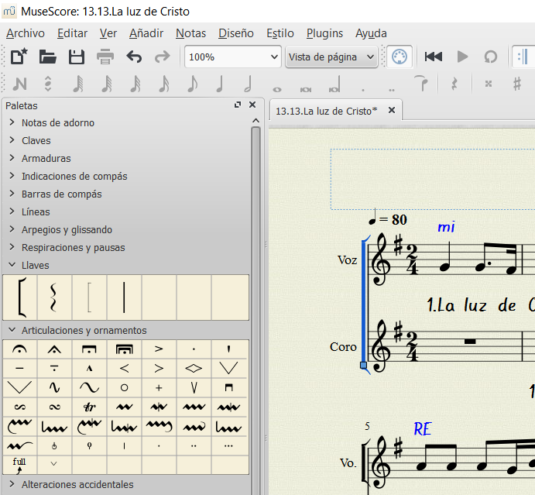
clasp returns to its original position.
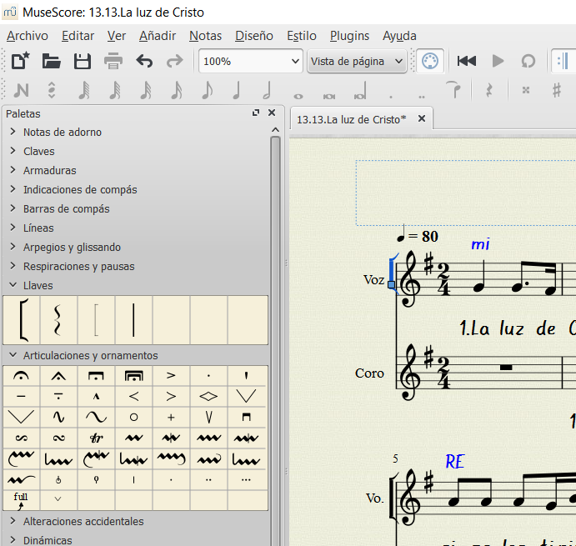

My SO is Windows 10
Thanks!

